**Chapter 6**

**Vector Calculus**

**6.3 Conservative Vector Fields**

**Section Exercises**

1. *True* or *False*. If vector field **F** is conservative on the open and connected region *D*, then line integrals of **F** are path independent on *D*, regardless of the shape of *D*.

Answer: True

1. *True* or *False*. Function  where  parameterizes the straight-line segment from 

Answer: True

1. *True* or *False*. Vector field  is conservative.

Answer: True

1. *True* or *False*. Vector field  is conservative.

Answer: False

1. Justify the Fundamental Theorem of Line Integrals for  in the case when  and *C* is a portion of the positively oriented circle  from (5, 0) to (3, 4).

Answer: 

1. **[T]** Find ,] where  and *C* is a portion of curve  from  to 

Answer: 

1. **[T]** Evaluate line integral , where  and *C* is the path given by  for 

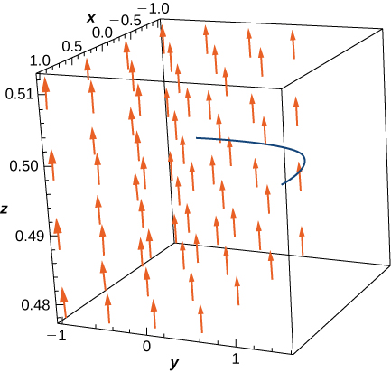

Answer: 

**For the following exercises, determine whether the vector field is conservative and, if it is, find the potential function.**

1. 

Answer: Conservative, 

1. 

Answer: Not conservative

1. 

Answer: Not conservative

1. 

Answer: Conservative, 

1. 

Answer: Conservative, 

1. 

Answer: Conservative, 

**For the following exercises, evaluate the line integrals using the Fundamental Theorem of Line Integrals.**

1. , where *C* is any path from (0, 0) to (2, 4)

Answer: 

1. , where *C* is the line segment from (0, 0) to (4, 4)

Answer: 

1. **[T]**  where *C* is any smooth curve from (1, 1) to 

Answer: 

1. Find the conservative vector field for the potential function

.

Answer: 

**For the following exercises, determine whether the vector field is conservative and, if so, find a potential function.**

1. 

Answer: **F** is conservative and a potential function is .

1. 

Answer: **F** is not conservative.

1. 

Answer: **F** is conservative and a potential function is 

1. 

Answer: **F** is conservative and a potential function is

1. 

Answer: **F** is not conservative.

1. 

Answer: **F** is conservative and a potential function is

1. 

Answer: **F** is not conservative.

1. 

Answer: **F** is conservative and a potential function is

**For the following exercises, determine whether the given vector field is conservative and find a potential function.**

1. 

Answer: **F** is not conservative.

1. 

Answer: **F** is conservative and a potential function is

**For the following exercises, evaluate the integral using the Fundamental Theorem of Line Integrals.**

1. Evaluate  where  and *C* is any path that starts at  and ends at 

Answer: 

1. **[T]** Evaluate  where  and *C* is a straight line from  to .

Answer: 

1. **[T]** Evaluate  where  and *C* is any path in a plane from (1, 2) to (3, 2).

Answer: 

1. Evaluate  where  and *C* has initial point (1, 2) and terminal point (3, 5).

Answer: 

**For the following exercises, let  and , and let *C*1 be the curve consisting of the circle of radius 2, centered at the origin and oriented counterclockwise, and *C*2 be the curve consisting of a line segment from (0, 0) to (1, 1) followed by a line segment from (1, 1) to (3, 1).**

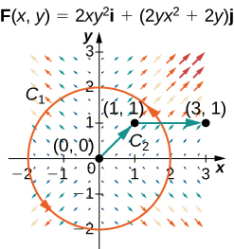 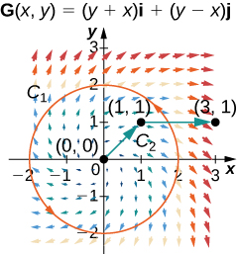

1. Calculate the line integral of **F** over *C*1.

Answer: 

1. Calculate the line integral of **G** over *C*1.

Answer: 

1. Calculate the line integral of **F** over *C*2.

Answer: 

1. Calculate the line integral of **G** over *C*2.

Answer: 

1. **[T]** Let . Calculate , where *C* is a path from  to

Answer: 

1. **[T]** Find line integral  of vector field  along curve *C* parameterized by 

Answer: 

**For the following exercises, show that the following vector fields are conservative by using a computer. Calculate  for the given curve.**

1.  *C* is the curve consisting of line segments from  to  to 

Answer: 

1.  *C* is parameterized by 

Answer: 

1. **[T]** *C* is curve 

Answer: 

1. The mass of Earth is approximately  and that of the Sun is 330,000 times as much. The gravitational constant is  The distance of Earth from the Sun is about  Compute, approximately, the work necessary to increase the distance of Earth from the Sun by 

Answer: 

1. **[T]** Let  Evaluate the integral , where 

Answer: 

1. **[T]** Let  be given by  Use a computer to compute the integral  where 

Answer: 

1. **[T]** Use a computer algebra system to find the mass of a wire that lies along curve  if the density is 

Answer: 

1. Find the circulation and flux of field  around and across the closed semicircular path that consists of semicircular arch  followed by line segment 

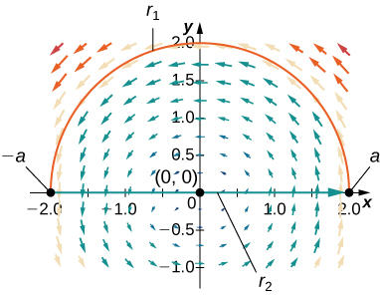

Answer: 

1. Compute , where 

Answer: 

1. Complete the proof of Theorem 1.9: The Path Independence Test for Conservative Fields by showing that 

Answer: This is a proof; therefore, no answer is provided.

This file is copyright 2016, Rice University. All Rights Reserved.